Market Research for Visa Inc.

Visa Inc. operates within the Financial Services industry, specifically focusing on the Payment Processing sector. This industry encompasses companies that facilitate electronic funds transfers, including credit card, debit card, and prepaid card transactions. Visa provides the infrastructure and technology that enable secure and efficient payment transactions between consumers, merchants, financial institutions, and governments worldwide.

Close Peers

Mastercard Incorporated
- Mastercard is a global leader in payment processing, offering a wide range of payment solutions including credit, debit, and prepaid cards.
- Like Visa, Mastercard operates a vast network facilitating electronic transactions between consumers, merchants, and financial institutions.
American Express Company (Amex)
- American Express is a multinational financial services corporation known for its charge and credit card products, as well as travel-related services.
- Amex competes with Visa in the credit card market, offering similar financial products and services aimed at consumers and businesses.

Substitutes and New Markets

Substitutes
- Cryptocurrencies: Digital currencies like Bitcoin and Ethereum offer alternative methods for transactions without traditional payment processors.
- Mobile Payment Solutions: Platforms such as Apple Pay, Google Pay, and Samsung Pay provide direct digital payment options, reducing reliance on traditional card networks.
- Buy Now, Pay Later (BNPL) Services: Companies like After pay and Klarna allow consumers to make purchases with deferred payments, bypassing traditional credit systems.
New Markets
- Fintech Innovations: Emerging financial technology firms are creating integrated payment solutions, peer-to-peer payment platforms, and blockchain-based systems.
- Developing Economies: Rapid digitalization in regions like Africa, Southeast Asia, and Latin America presents opportunities for expanding electronic payment adoption.
- Internet of Things (IoT) Payments: Integration of payment systems with IoT devices (e.g., smart appliances, wearable tech) opens new avenues for transactions.

Key Revenue and Cost Drivers

Revenue Drivers
- Transaction Fees: Revenue from processing payments for merchants and financial institutions, including interchange fees and service fees.
- Data Processing Services: Income from providing data analytics, fraud prevention, and security solutions to clients.
- Value-Added Services: Additional offerings such as loyalty programs, consulting services, and customized payment solutions.

Cost Drivers
- Technology and Infrastructure: Investments in payment processing technology, cybersecurity measures, and IT infrastructure maintenance.
- Marketing and Sales: Expenses related to promoting Visa’s services, acquiring new customers, and maintaining merchant partnerships.
- Compliance and Regulatory Costs: Costs associated with adhering to financial regulations, data protection laws, and industry standards across different regions.

Current Industry/Market Trends in Relation to Revenue and Cost Drivers

- Shift to Digital and Contactless Payments: Increased consumer preference for digital wallets and contactless transactions drives higher transaction volumes, boosting revenue from fees.
- E-commerce Growth: The expansion of online shopping platforms enhances demand for secure and efficient payment processing services, contributing to revenue growth.
- Fintech Collaboration and Competition: Partnerships with fintech startups can lead to innovative payment solutions, while competition may pressure fee structures and margins.
- Advancements in Technology: Continuous investment in AI, machine learning, and blockchain technologies can improve security and efficiency but also increase operational costs.
- Regulatory Changes: Evolving financial regulations require ongoing compliance efforts, impacting cost structures and operational flexibility.
- Cybersecurity Threats: Rising threats necessitate significant investments in cybersecurity measures to protect transaction data and maintain consumer trust.

SWOT Analysis

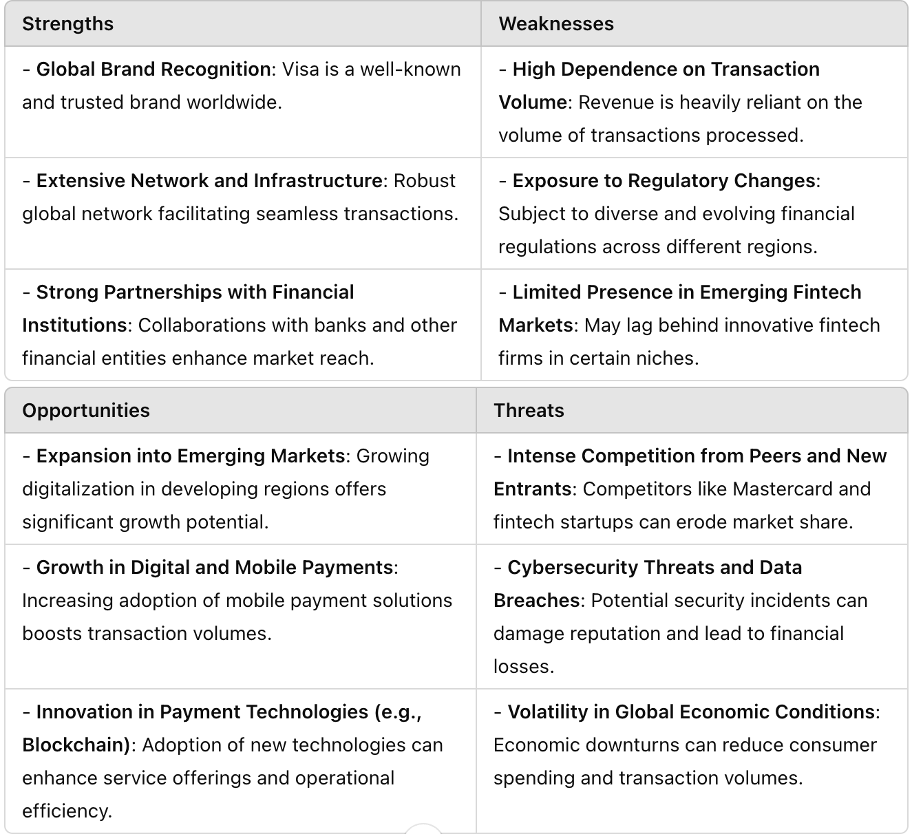

PESTEL Analysis

Factor | Description
Political | - Regulatory Environment: Compliance with international financial regulations and local laws affecting payment processing.  - Trade Policies: Impact of international trade agreements and tariffs on global operations.  - Government Stability: Political stability in key markets influencing business continuity.
Economic | - Global Economic Growth: Economic performance affects consumer spending and transaction volumes.  - Exchange Rate Fluctuations: Impact on revenues from international transactions.  - Interest Rates: Influence on consumer credit usage and borrowing costs.
Social | - Consumer Preferences: Shift towards digital and contactless payments.  - Demographics: Younger populations more inclined to adopt digital payment methods.  - Cultural Factors: Variations in payment preferences across different regions.
Technological | - Advancements in Payment Technologies: Adoption of AI, machine learning, and blockchain to enhance payment solutions.  - Cybersecurity Innovations: Development of advanced security measures to protect transaction data.  - Fintech Integration: Collaboration with fintech firms to innovate and expand service offerings.
Environmental | - Sustainability Initiatives: Commitment to reducing carbon footprint and promoting sustainable practices.  - Energy Consumption: Managing energy usage related to data canters and IT infrastructure.  - Regulatory Requirements: Adherence to environmental regulations in various jurisdictions.
Legal | - Data Protection Laws: Compliance with regulations like GDPR for handling consumer data.  - Intellectual Property Rights: Protecting proprietary technologies and innovations.  - Litigation Risks: Potential legal challenges related to antitrust, data breaches, and other issues

Competitive Environment Analysis

Market Share and Performance
- Visa Inc. is a leading player in the global payment processing market, holding a substantial market share. It competes closely with Mastercard, which similarly commands a significant portion of the market.
- American Express (Amex), while smaller in overall market share, differentiates itself with premium services and a strong focus on customer loyalty.

Key Strategies
Visa Inc.:
- Innovation and Technology Investment: Continuously investing in cutting-edge payment technologies, including blockchain and AI, to enhance transaction security and processing efficiency.
- Strategic Partnerships: Collaborating with financial institutions, fintech startups, and technology companies to expand its ecosystem and integrate services with emerging platforms.
- Global Expansion: Targeting growth in emerging markets by increasing the adoption of digital payments and expanding merchant networks.
- Focus on Security: Enhancing cybersecurity measures and fraud prevention tools to maintain consumer trust and comply with regulatory standards.

Mastercard:
- Diversification of Services: Expanding beyond traditional payment processing to include data analytics, cybersecurity, and digital identity verification.
- Fintech Collaborations: Partnering with fintech firms to develop innovative payment solutions and enter new market segments.
- Sustainability Initiatives: Committing to environmental sustainability through initiatives aimed at reducing carbon footprint and promoting responsible business practices.
American Express:
- Premium Customer Focus: Offering high-end services, exclusive rewards, and superior customer service to attract affluent customers and businesses.
- Global Reach Enhancement: Expanding its international presence through strategic partnerships and targeted marketing in key regions.
- Technological Advancements: Investing in digital platforms and mobile payment solutions to stay competitive in the evolving payment landscape.

Competitive Advantages
- Visa Inc.:
  - Extensive Global Network: Visa’s widespread acceptance and robust infrastructure provide a significant competitive edge.
  - Strong Brand Equity: High brand recognition and consumer trust facilitate market penetration and customer loyalty.
  - Advanced Technological Capabilities: Leading in payment processing technology and cybersecurity measures ensures secure and efficient transactions.
- Mastercard:
  - Service Diversification: Offering a broader range of services beyond payment processing helps mitigate risks and tap into new revenue streams.
  - Innovation Focus: Strong emphasis on innovation and technology keeps Mastercard at the forefront of the payment industry.
- American Express:
  - Premium Branding: Positioning as a premium service provider attracts a niche market willing to pay for superior services.
  - Customer Loyalty Programs: Comprehensive rewards and loyalty programs enhance customer retention and satisfaction.

Challenges and Threats
- Fintech Disruption: Emerging fintech startups offering innovative and cost-effective payment solutions pose a threat to traditional payment processors like Visa.
- Regulatory Pressures: Increasing regulatory scrutiny and compliance requirements can lead to higher operational costs and limit strategic flexibility.
- Cybersecurity Risks: Rising cyber threats necessitate continuous investment in security measures to protect transaction data and maintain trust.
- Economic Volatility: Fluctuations in global economic conditions can impact consumer spending patterns and transaction volumes, affecting revenue growth.

Performance Evaluation
- Visa Inc. has maintained robust financial performance with consistent revenue growth driven by increasing digital transactions and global expansion. Its strategic focus on technology and partnerships has solidified its market position.
- Mastercard exhibits similar growth trends, with strong emphasis on service diversification and innovation contributing to its competitive stance.
- American Express shows steady performance within its niche market, leveraging premium services and customer loyalty to sustain growth.

Visa Inc. stands as a dominant player in the global payment processing industry, leveraging its extensive network, strong brand, and continuous innovation to maintain its competitive edge. While facing challenges from fintech disruptors, regulatory complexities, and cybersecurity threats, Visa's strategic initiatives in technology investment, global expansion, and strategic partnerships position it well for sustained growth. Understanding the competitive landscape, key industry trends, and internal strengths and weaknesses through SWOT and PESTEL analyses provides a comprehensive view of Visa’s market standing and future opportunities.

